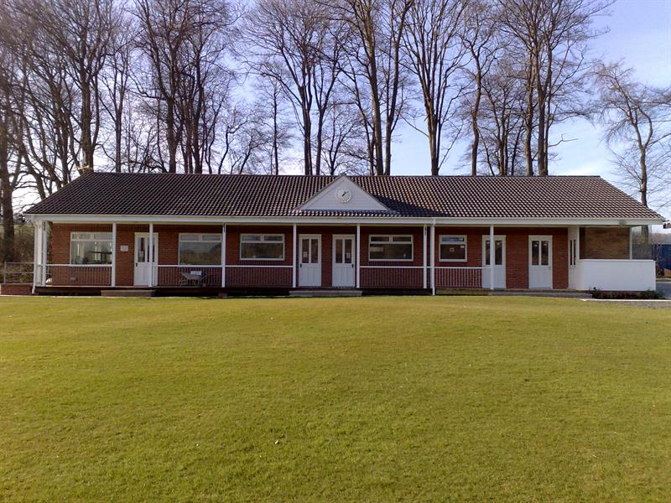L

LL
Londesborough Park Risk Assessment re Covid-19

What are the hazards? |  | Transmission of COVID-19
Who might be harmed? |  | Facility users, staff, volunteers, visitors and the wider community
No | Controls required |  | Action Taken
People Management and Communication
 | Self-screening of individuals before they arrive at the venue to ensure individuals displaying COVID-19 symptoms or those who should be shielding do not travel or attend. |  | The club will email the Covid-19 Plan for Junior & Open Age Cricket Form to all visiting clubs to be circulated to all players and participants, and to our own club members.
 | An assessment of user numbers, space capacities, venue circulation and layout planning to maintain social distancing. |  | Max 30 participants to be collated by team captains on match days. Visitors using toilet facilities contact details also to be collated and sent to Club Secretary at the end of match days
 | A plan for where parents and players will sit whilst watching cricket activities. |  | Players to have designated areas clearly marked, limited benches around the ground for spectators with Social Distancing posters. Clubhouse to remain closed at present
 | Signage and communication so that all participants and visitors are aware of the control measures in place and how to act appropriately to minimise the risk of transmission of COVID-19. |  | Entrance/exit instructions clearly signposted on arrival. Toilet queuing system with cleaning instructions clearly signed, and contact details form clearly displayed. Social distancing posters around the ground. Player conduct posters also displayed. Frequent hand washing signs also in place.
 | Staff and volunteer training to support the implementation of the plan, with suitable training records. |  | Hygiene certificates available, Covid-19 Committee fully trained on plans and procedures
Buildings
 | Assess ventilation in your building (natural and mechanical) and take appropriate measures to maximise ventilation and minimise risk of transmission. |  | Clubhouse to remain closed at present. Toilet window and door to be open on match days.
 | Assess the maximum occupancy of your rooms at 2m social distancing (or 1m with risk mitigation where 2m is not possible) and establish a suitable circulation system/one-way system. Use signage and floor markings to communicate this. |  | N/A club house closed
 | Assess the arrangement of seating areas to maintain social distancing and minimise the risk of transmission. |  | Outdoor benches arranged with social distancing in place.
 | Consider your wet weather plans and describe what actions you will take to maintain social distancing in wet weather. |  | All participants and spectators to return to their cars. Poster explaining safe use of wicket covers in place.
Social and Hospitality Areas
 | Plan to solicit and maintain records of your member attendance, customers and visitors - to be maintained for 21 days and then destroyed. |  | Email to be sent to visiting clubs prior to matches to collate participant information. All data to be collated by team captain on match day of any participant and visitors/spectators using toilet facilities and sent to Club Secretary to keep for 21 days.
 | Identification of suitable areas for outdoor service that don’t overlap with cricket activity. |  | N/A no other services
 | Steps taken to minimise time and the number of people at the bar. |  | N/A
 | Steps taken to minimise contact points at payment or around the hospitality space. |  | N/A
 | Suitable PPE provision and training for staff and volunteers. |  | Covid-19 committee and Fist Aiders trained on use of PPE. First aid box stocked with PPE. Instruction poster in First Aid box.
 | Strategy for the safe serving, clearing and cleaning of glassware and tableware. |  | N/A clubhouse currently closed
 | Deep cleaning strategy to minimise COVID-19 transmission risk |  | Deep clean to take place in between match days.
 | Daily cleaning strategy to minimise COVID-19 transmission risk. |  | Cleaning to take place after each match. Paper towels rubbish in toilets to be removed. No other dustbins on site, posters to ask all people to take home their own rubbish
 | High-frequency touchpoint cleaning strategy to minimise COVID-19 transmission risk and how you will keep records. |  | Poster to ask Toilet users to clean after every use with sanitizer provided. Frequent hand sanitizer posts at entry/exit, toilet door, equipment store and nets with posters to remind.
Hygiene and Cleaning
 | Materials, PPE and training that you have provided to your staff for effective cleaning. |  | Covid-19 committee fully trained as per government guidelines
 | Provision of hand washing facilities with warm water, soap, disposable towels and bin. |  | Sanitizer provided for frequent toilet cleaning, soap and paper towels with bin for handwashing in toilet. Bin to be emptied after every match and provisions restocked.
 | Provision of suitable hand sanitiser in locations around the facility to maintain frequent hand sanitisation. |  | High contact points have hand sanitizer fixed in place, at entry/exit points, toilets, equipment store and nets. To be restocked prior to every match.
 | Provision of suitable wipes and hand sanitiser on the field for hygiene breaks. |  | All participants instructed to bring their own hand sanitizer. Captains to be issued with wipes and spare sanitizer for participants if required.
 | What are the hazards? | Other venue hazards to be considered after temporary closure such as Legionnaire’s Disease, fire, electrical safety etc.
 | Who might be harmed? | Facility users, staff, volunteers and visitors
 | Controls required |  | Action Taken by the Club
Preparing Your Buildings
 | Consider the risk of Legionnaire’s disease and carry out necessary work to make your water supply safe for users. Refer to the specific guidance in the document above. |  | Plumber certified ok
 | Check that routine maintenance has not been missed and certification is up to date (e.g. Gas safety, Electrical Safety and Portable Appliance Testing, Fire Safety, Lifts and Heating – Ventilation and Air Conditioning). |  | All certification up to date and routinely inspected
 | Check that your ground is ready and safe to play. Look at what work is required and how this can be done safely at a social distance. |  | Ground had continual work since April, committee have inspected, and the ground is ready.
 | What are the hazards? | Vital first aid equipment is not available when needed. First aiders do not have adequate PPE to carry out first aid when required.
 | Who might be harmed? | First aiders, facility users, staff, volunteers and visitors
 | Controls required |  | Action Taken by the Club
First Aid
 | Check that your first aid kits are stocked and accessible during all activity. |  | First aid kit fully stocked, hand sanitizer and PPE added with instructions as per St Johns Ambulance included
 | What steps have you taken to improve your first aiders’ understanding of first aid provision under COVID-19? |  | First Aid guidance by St. Johns Ambulance as per ECB recommendations printed and with First Aid kit.
 | If you have an AED then check that it is in working order, service is up to date and that it is available during all activity. |  | Weekly checks undertaken, pads expire Sept 2020, committee aware.
 | What are the hazards? | Pitches or outfield are unsafe to play on
 | Who might be harmed? | Players, officials, ground staff
 | Controls required |  | Action Taken by the Club
Preparing your Grounds
 | Safety checks on machinery, sightscreens and covers. |  | Regularly undertaken by ground staff
 | Check and repair of any damage to pitches and outfields. |  | As above
 | Surfaces checked and watering regime adjusted based on lack of rainfall. |  | As above
 | What are the hazards? | Use this space to identify hazards at your venue
 | Who might be harmed? | Use this space to identify who might be harmed
 | Controls required |  | Action Taken by the Club
 | Identify your own control measures required. |  | Committee to review plan and develop plan as per any changes advised by government or the ECB
 |  |  | Electronic scoreboard not to be used at present or scorebox. Outside portable scoreboard to be used and cleaned after matches with sanitizer provided.
 |  |  | 2 committee members to be present at 1st match to oversee plans are put into practice and to advise any participants or visitors of procedures.
 |  |  | Pre match and post match checklists to be completed by a club member and given to club secretary to be held for 21 days with contact details of participants and visitors

 | What are the hazards? | Use this space to identify hazards at your venue
 | Who might be harmed? | Use this space to identify who might be harmed
 | Controls required |  | Action Taken by the Club
 | Identify your own control measures required.

 | What are the hazards? | Use this space to identify hazards at your venue
 | Who might be harmed? | Use this space to identify who might be harmed
 | Controls required |  | Action Taken by the Club
 | Identify your own control measures required.

